The MyPhone X

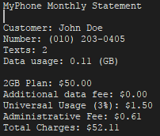

Silas Agnew

I pledge that this work is entirely mine, and mine alone (except for any code provided by my instructor).

I spent 4 hours and 20 minutes on the project from Sept. 26 to Sept. 28. See time sheet on back for more detail.

Time Sheet

|  |  |  |  |  |
| --- | --- | --- | --- | --- |
| Date | Time Started | Time Stopped | Duration | Worked on… |
| 9/26/2017 | 20:00:00 | 20:30:00 | 00:30:00 | Setup project and timesheet; started template methods |
| 9/28/2017 | 15:00:00 | 17:00:00 | 02:00:00 | Commented and worked on methods |
| 9/28/2017 | 20:10:00 | 21:00:00 | 00:50:00 | Finished up methods |
| 9/28/2017 | 21:00:00 | 22:00:00 | 01:00:00 | Project papers and printouts |
|  |  |  |  |  |
|  |  | Total Time | 04:20:00 |  |